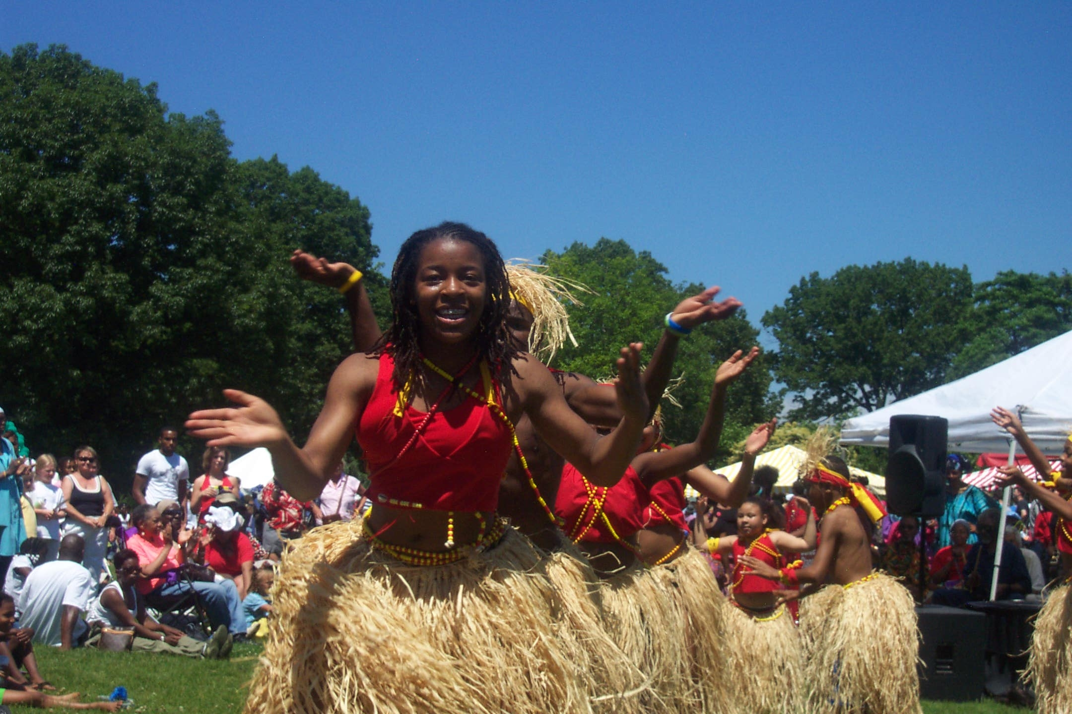


African Dance and Drum Class

Saturday’s
12-12:45 a.m. Ages 3-6
1:00- 2:30 p.m. Ages 7- Adult
*Drum classes are for all ages, once enrolled you can play for both classes

Masonic Temple– 3615 Euclid Ave.-Downtown
*Newly Renovated, air-conditioned studios*

Summer Class session:

June 21-August 16^{th*----}Class recital August 16th
Registration – Full session: $60 for adults, $30 for children under 13
Or just drop in -- per class cost: $12 adults, $7 children

For more information call
216.451.SOUL (7685) or 216.224.5409 or
sistajewel@yahoo.com or www.africansoulinternational.org

African Soul International specializes in innovative, creative and artistic solutions to address educational and social issues within the community. African Soul International offers the community a view of the world through dance and drums…

*There will be no class on July 5th or July 26th.
Some scholarships available through Neighborhood Connections. Email for audition.

